Ideation Phase
Define the Problem Statements

Date | 31 January 2025
Team ID
Project Name | DocSpot
Maximum Marks | 2 Marks

Customer Problem Statement Template:
To define the core problems where doctor, patient and admin face while booking appointments online, and use those insights to guide the development of Doctor Appointment System.
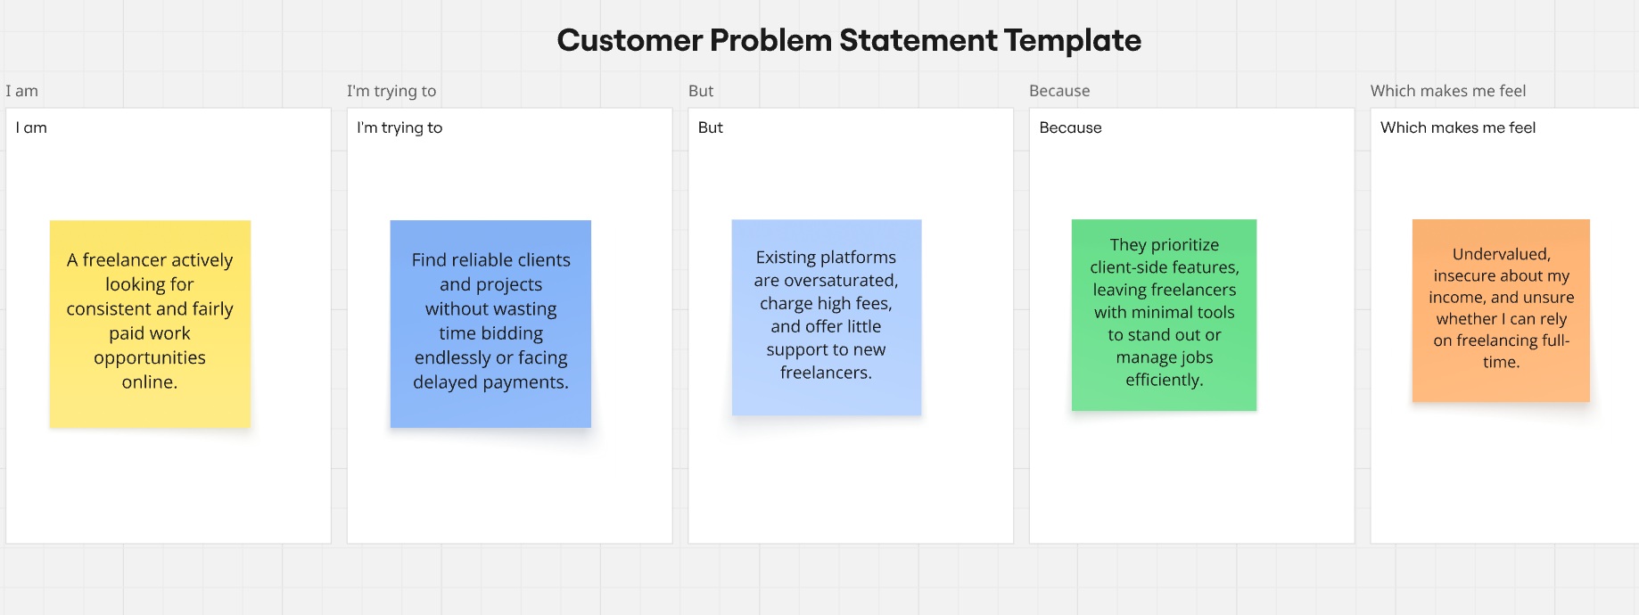
Reference: https://miro.com/templates/customer-problem-statement/

Problem Statement (PS) | I am (Customer) | I’m trying to | But | Because | Which makes me feel
PS-1  (Patient Perspective) | A patient actively looking for convenient and reliable doctor appointments online | Land steady appointments with doctors without confusion or uncertainty | Many clinics operate with outdated systems or unclear availability schedules | Most healthcare providers don't have real-time appointment systems with transparent workflows | Frustrated, anxious, and uncertain about getting timely medical care
PS-2  (Clinic/Administrator Perspective) | A clinic manager or administrator responsible for scheduling and patient management | Manage doctor schedules and patient appointments efficiently | Manual scheduling creates confusion,duplicate bookings, and administrative overhead | Current systems lack automation and proper rolebased access control | Overwhelmed with administrative tasks and unable to focus on patient care quality
PS-3  (Doctor Perspective) | A healthcare professional managing my patient appointments and schedules | View my schedule clearly and manage patient appointments efficiently | Many booking systems don't provide real-time updates or easy cancellation management | Existing solutions lack role-based interfaces designed specifically for doctors | Frustrated with system limitations and unable to optimize my time

